
PRESS RELEASE | GENEVA | 7 NOVEMBER 2022

CHRISTIE’S GENEVA WATCH AUCTIONS
TOTAL CHF 55 MILLION

17 lots selling above CHF1 Million
40% new bidders

2 Live Auctions:
Legendary and Unique Watches realising CHF31,877,418 / $31,679,596
Rare Watches realising CHF23,669,670 / $23,859,366

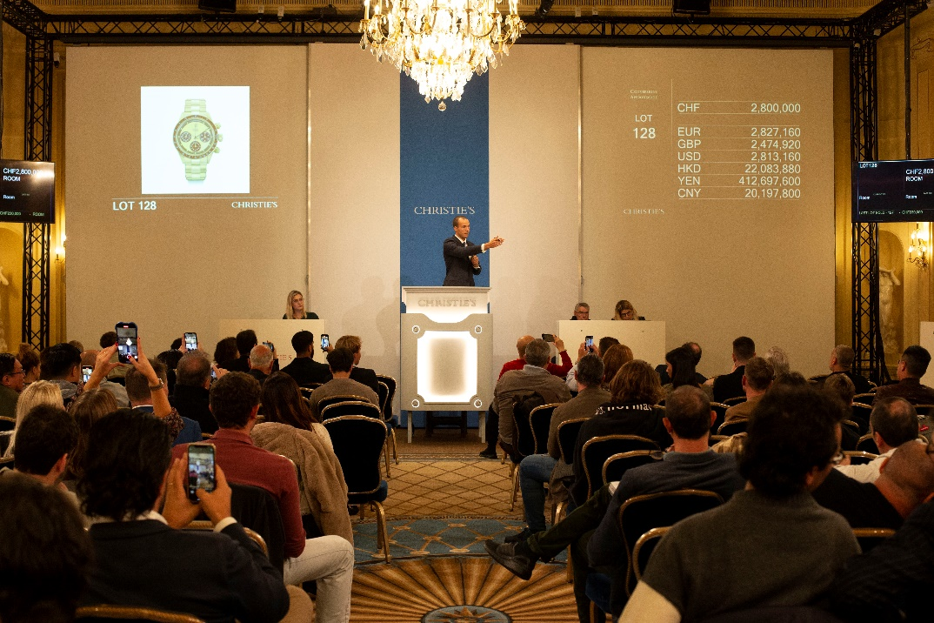
Max Fawcett selling the top lot of the auction, a Rolex Daytona, ref. 6263 selling for CHF3,414,000

Geneva – A historic moment during this autumn Geneva watch season. Christie’s leads the watch auction market in Geneva, achieving a total of CHF55,548,348 /$55,540,232 / Euro56,302,789 / HK$433,841,034 across the two sales.
The week started with Legendary and Unique Watches, a white glove sale, followed by the Rare Watches auction where 238 lots out of 239 lots found a new owner. The two watch auctions, held on 6 and 7 November at Geneva’s Four Seasons Hotel des Bergues, attracted 40% new bidders, with a record attendance online as well as live in-room participation.
Christie’s outstanding result demonstrates the savoir-faire of its young and dynamic team bringing to auction one of the most important private collections (Legendary and Unique Watches) and horology masterpieces, contested by bidders from 46 countries. Incredible results were achieved, including for lot 34, Patek Philippe reference 5711/1A-018, additionally signed Tiffany & Co., selling above estimate for CHF3,174,000 (against a retail price of USD52,000).
Remi Guillemin, Head of Christie’s Geneva Watch department commented: ”Holding two high calibre auctions with incredible sell through rates of 100% and 99% within 24 hours is an unseen moment in watch auction history. Our gratitude goes to our worldwide collectors, confirming Christie’s Geneva as a special place for Rolex and masterpieces.”

TOP LOTS OF THE RARE WATCHES AUCTION 7 NOVEMBER

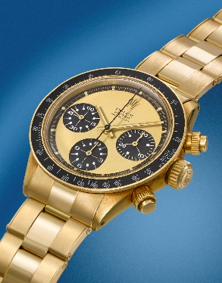 | TOP LOT – Lot 128  Rolex Daytona, Paul Newman Model  REF 6263  Estimate  CHF 3-5 million  Price realised  CHF3,414,000
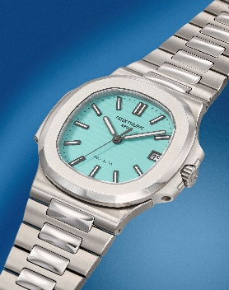 | LOT 34  Patek Philippe  Nautilus Model, additional signed Tiffany & Co  REF 5711/1A-018  Estimate  1.5-3 million  Price realised  CHF3,174,000
 | LOT 92  Patek Philippe  Additionally signed Cartier  REF 1518  Estimate  1.5-2.6 million  Price realised  CHF2,214,000
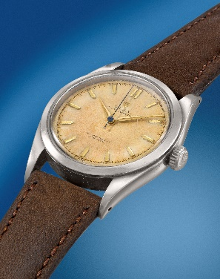 | LOT 127  Rolex  Pre-Explorer Model  REF 6298  Estimate  CHF 20-40,000  Price realised  CHF289,800

_____________________________________________________________________________________
PRESS CONTACTS:

Christie’s EMEA | Global watch & watchmaking media
Alexandra Kindermann  akindermann@christies.com  +41 79 101 41 96 | 289 Consulting  Marine Lemonnier-Brennan  marine.lemonnier@289consulting.com  +41 79 389 67 62  Aude Campanelli  aude.campanelli@289consulting.com  +41 78 637 16 91

About Christie’s

Founded in 1766, Christie’s is a world-leading art and luxury business. Renowned and trusted for its expert live and online auctions, as well as its bespoke private sales, Christie’s offers a full portfolio of global services to its clients, including art appraisal, art financing, international real estate and education. Christie’s has a physical presence in 46 countries, throughout the Americas, Europe, Middle East, and Asia Pacific, with flagship international sales hubs in New York, London, Hong Kong, Paris and Geneva. It also is the only international auction house authorized to hold sales in mainland China (Shanghai).
Christie’s auctions span more than 80 art and luxury categories, at price points ranging from $200 to over $100 million. In recent years, Christie’s has achieved the world record price for an artwork at auction (Leonardo da Vinci’s Salvator Mundi, 2017), for a 20th century artwork (Andy Warhol’s Shot Sage Blue Marilyn, 2022) and for a work by a living artist (Jeff Koons’ Rabbit, 2019). Christie's is also recognised as a reference for prestigious single owner collections, having auctioned 8 of the 10 most important collections in history.
Christie’s Private Sales offers a seamless service for buying and selling art, jewellery and watches outside of the auction calendar, working exclusively with Christie’s specialists at a client’s individual pace.
Recent innovations at Christie’s include groundbreaking sale of the first NFT for a digital work of art ever offered at a major auction house (Beeple’s Everydays, March 2021), with the unprecedented acceptance of cryptocurrency as a means of payment. As an industry leader in digital innovation, Christie’s also continues to pioneer new technologies that are redefining the business of art, including the use of hologram technology to tour life-size 3D objects around the world, and the creation of viewing and bidding experiences that integrate augmented reality, global livestreaming, buy-now channels, and hybrid sales formats.
Christie’s is dedicated to advancing responsible culture throughout its business and communities worldwide, including achieving sustainability through net zero carbon emissions by 2030, and actively using its platform in the art world to amplify under-represented voices and support positive change.
Browse, bid, discover, and join us for the best of art and luxury at: www.christies.com or by downloading Christie’s apps.

*Please note when quoting estimates above that other fees will apply in addition to the hammer price - see Section D of the Conditions of Sale at the back of the sale catalogue.
*Estimates do not include buyer’s premium. Sales totals are hammer price plus buyer’s premium and are reported net of applicable fees.

# # #

FOLLOW CHRISTIE’S ON:


