
PRESS RELEASE | NEW YORK | FOR IMMEDIATE RELEASE: 28 SEPTEMBER 2023
MONET’S NEVER-BEFORE-SEEN MASTERPIECE LE BASSIN AUX NYMPHÉAS WILL HIGHLIGHT CHRISTIE’S 20TH CENTURY EVENING SALE
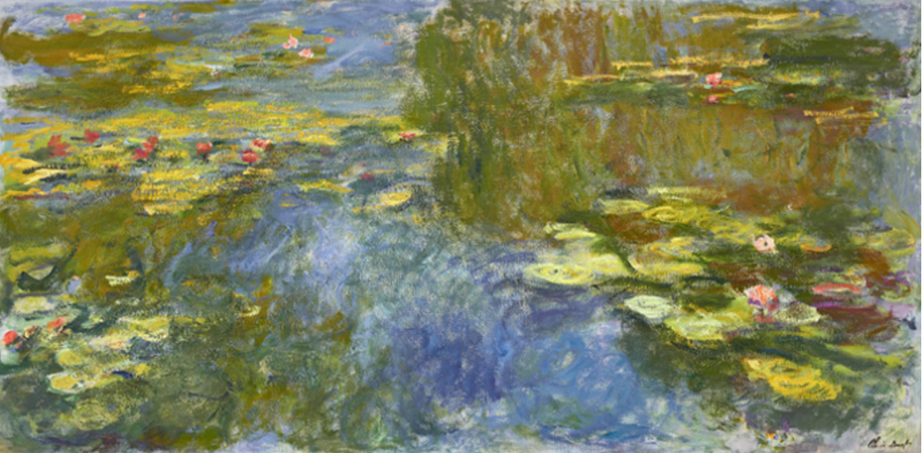
CLAUDE MONET (1840-1926)
Le bassin aux nymphéas
oil on canvas
Painted circa 1917-1919
Estimate on request

NEW YORK – Christie’s is proud to present Le bassin aux nymphéas, one of the artist’s monumental canvases from his celebrated water lily series, as the leading highlight of the 20th Century Evening Sale on November 9, 2023. Modern and timeless, Le bassin aux nymphéas captures the dynamism and beauty of nature’s transience, exploring the ephemeral atmosphere, seasonal blooms, watery depths, and glimmering reflections of light of Monet’s famed lily pond in Giverny. This superb example has been held in the same family collection for over fifty years. It is estimated to realize in excess of $65 million.

Max Carter, Christie’s Vice Chairman of 20th and 21st Century Art, remarks: “With Monet, seemingly everything has already been seen or said. Le bassin aux nymphéas, which has never been exhibited or offered at auction, is, however, that rarest thing: A masterpiece rediscovered. Thickly worked, impeccably preserved and hidden away in the same private collection since 1972, Le bassin aux nymphéas remains as astonishing today as it was 100 years ago. We are thrilled to unveil it publicly for the first time on October 4th in Hong Kong.”

Landmarks of late Impressionism, the paintings Monet made of his Giverny gardens are some of the most innovative and influential works of his oeuvre. In the final 25 years of his life, Monet became devoted to capturing the scenic grounds of his home, producing a richly complex and diverse body of work. Le bassin aux nymphéas is a key example from this famed series of works dedicated to the waterlilies, measuring more than two meters wide. A Monet Nymphéas of this scale and quality has not come to auction since a canvas in the historic May 2018 sale of The Collection of Peggy and David Rockefeller achieved a price of $84.7 million.

Le bassin aux nymphéas dates from 1917-1919, an all-important period of experimentation in Monet’s practice during which he achieved a new painterly vision of the lily-pond, sparked by his desire to create mural size images of the motif rather than the smaller water landscapes he had been creating prior. These grand, monumental depictions were filled with gestural, vigorous bolts of color that coalesce to form the watery landscape, the vibrancy and gestural quality of the brushwork revealing the impressive energy that lay behind the artist’s paintings, even at this late stage of his career. These revolutionary compositions were initially met with mixed reactions from Monet’s contemporaries, but later found favor among a younger generation of artists and collectors in the later decades of the 20th century, notably with the painters of the burgeoning Abstract Expressionist movement. Monet’s paintings of the water lilies are now among the most highly coveted and celebrated Impressionist masterpieces of his oeuvre, with examples held in the most esteemed private and institutional collections around the world.

IMAGES FOR PRESS USE AVAILABLE HERE.

PRESS CONTACT: Jessica Stanley | jstanley@christies.com | 212 636 2680

About Christie’s
Founded in 1766, Christie’s is a world-leading art and luxury business with a physical presence in 46 countries throughout the Americas, Europe, Middle East, and Asia Pacific, and flagship international sales hubs in New York, London, Hong Kong, Paris and Geneva. Renowned and trusted for our expert live and online-only auctions, as well as bespoke Private Sales, Christie’s unparalleled network of specialists offers our clients a full portfolio of global services, including art appraisal, art financing, international real estate and education. Christie’s auctions span more than 80 art and luxury categories, at price points ranging from $500 to over $100 million. Christie’s has sold 8 of the 10 most important single-owner collections in history, achieved the world record price for an artwork at auction, launched the first fully on-chain auction platform dedicated to exceptional NFT art and manages an investment fund to support innovative startups in the art market. Christie’s is also committed to advancing responsible culture throughout its business and communities worldwide. To learn more, browse, bid, discover, and join us for the best of art and luxury at christies.com or by downloading Christie’s apps.
* Please note when quoting estimates above that other fees will apply in addition to the hammer price - see Section D of the Conditions of Sale at the back of the sale catalogue.
*Estimates do not include buyer’s premium. Sales totals are hammer price plus buyer’s premium.



